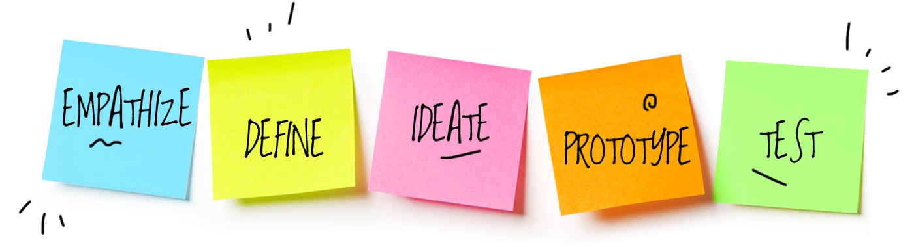Design Thinking Process

The design thinking process at its core is all about [user-centered design](https://www.o8.agency/blog/user-centered-design-principles-process-examples). The user’s journey, motivations, and pain points are present in all steps of the process to create a tailored solution. It is a solution-focused, problem-solving methodology that helps companies, and individuals alike to get a desired outcome on an inner problem, or to work forward on a future plan. Design Thinking allows for the user of the system to have a more structured plan for understanding innovation and to grow more as a company. Design Thinking is a way to understand the **client’s needs** (including their users’ needs) in depth, before taking a creative and solution-oriented approach to meeting those needs. Some of the essential features of the **Design Thinking process** include empathy, collaboration, questioning, creativity, exploration, experimentation, and continuous improvement. Sounds good, but what is it?

While definitions of Design Thinking may vary, depending on the source, the core feature of Design Thinking is the customer. Whatever stage of the design process you’re at, the focus on people – especially the product user – is essential. Without that, it’s just not Design Thinking.

Design Thinking Process

The best way to understand Design Thinking and its applications is to look at the process itself. Though different schools of thought tend to create their own versions of that process, a ‘classic’ 5-phase version comes from Stanford University’s school:

* **Empathy** – get to know the users.
* **Definition**– understand what users need, gather insights into the issues underpinning the problem (dig deep enough and almost certainly, the original problem statement is incomplete or oversimplified).
* **Ideation** –challenge assumptions, storm ideas, give free reign to innovation.
* **Prototyping** – create a solution that solves at least part of the problem.
* **Testing** – test the prototype with users and gather feedback.

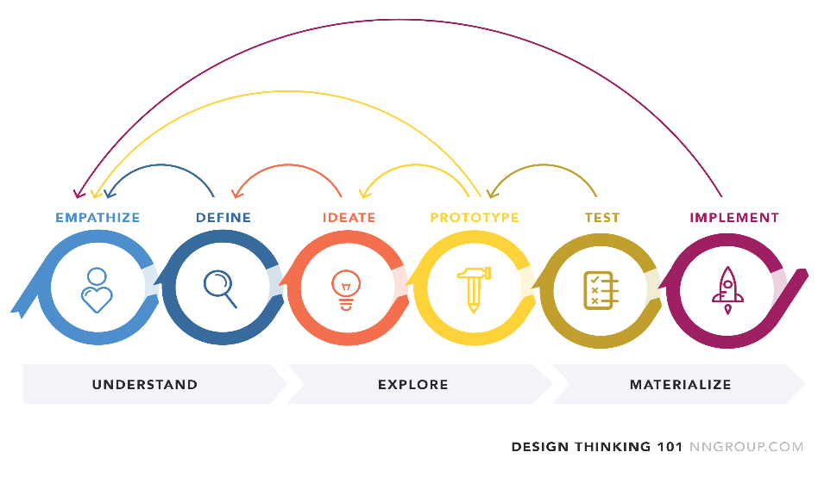

Real Time Example Of Design Thinking Process

NETFIX

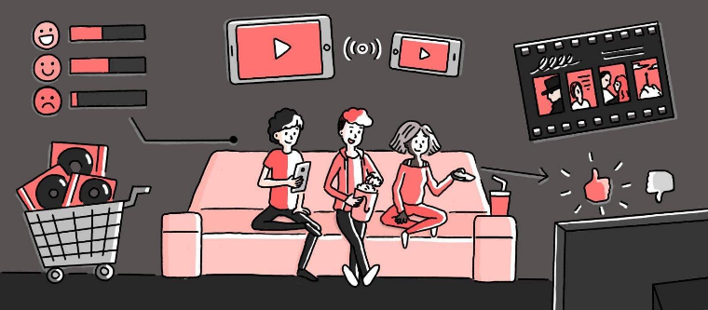

According to [**Forbes**](https://www.forbes.com/sites/chunkamui/2011/03/17/how-netflix-innovates-and-wins/?sh=6bc3adf961f3), back in 2001, Netflix founder Reed Hastings spent $10 million a year on streaming technology research. This fact alone shows how customer-centric Netflix has been from its very beginning.

In the same article, the author points out that Netflix's design thinking can be boiled down to four rules:

1. **Think Big** - Netflix was not afraid to destroy its existing successful DVD delivery business and follow the technological advance.

2. **Start small** - the company did not rush headlong into the implementation of a new product, but waited for the right moment.

3. **Fail quickly** - Early streaming attempts were abandoned.

4. **Scale Fast** - Netflix has been able to grow rapidly by moving to the original content.

Many of us are familiar with all the advantages of the Netflix platform and its [**human-centered UX design**](https://www.eleken.co/blog-posts/human-centered-design-examples-for-better-user-experience):

* Card design (you can interact with each card: pick it, bring closer, flip over, etc.)



* AI-powered recommendations (based on your view history Netflix personalize the experience for you)

But Netflix's design thinking goes beyond digital design. It covers the entire process of user interaction with the system.

Making the customer a top priority and continually thinking about what would be better for them helped Netflix to not only reshape the video rental industry but also let Netflix become an essential part of how to relax correctly. Because let's be real, there's "Chill" and there's "Netflix and Chill".